**Pivotal Cloud Foundry Deployment steps**

1. Install Cloud Foundry CLI

URL : <https://docs.cloudfoundry.org/cf-cli/install-go-cli.html#windows>

**Windows Installation**

To use the cf CLI installer for Windows, perform the following steps:

1. Download [the Windows installer](https://cli.run.pivotal.io/stable?release=windows64&source=github).
2. Unpack the zip file.
3. Double click the cf CLI executable.
4. When prompted, click **Install**, then **Close**.
5. To verify your installation, open a terminal window and type cf. If your installation was successful, the cf CLI help listing appears.
6. Make sure you having access for Github as well(<https://github.com/>) to down the latest code
7. Download the project from Github
8. Open command prompt and navigate the project folder.
9. **Execute** cf login -a <https://api.cfsys-gcg-gtdc1.citipaas-dev.dyn.nsroot.net>

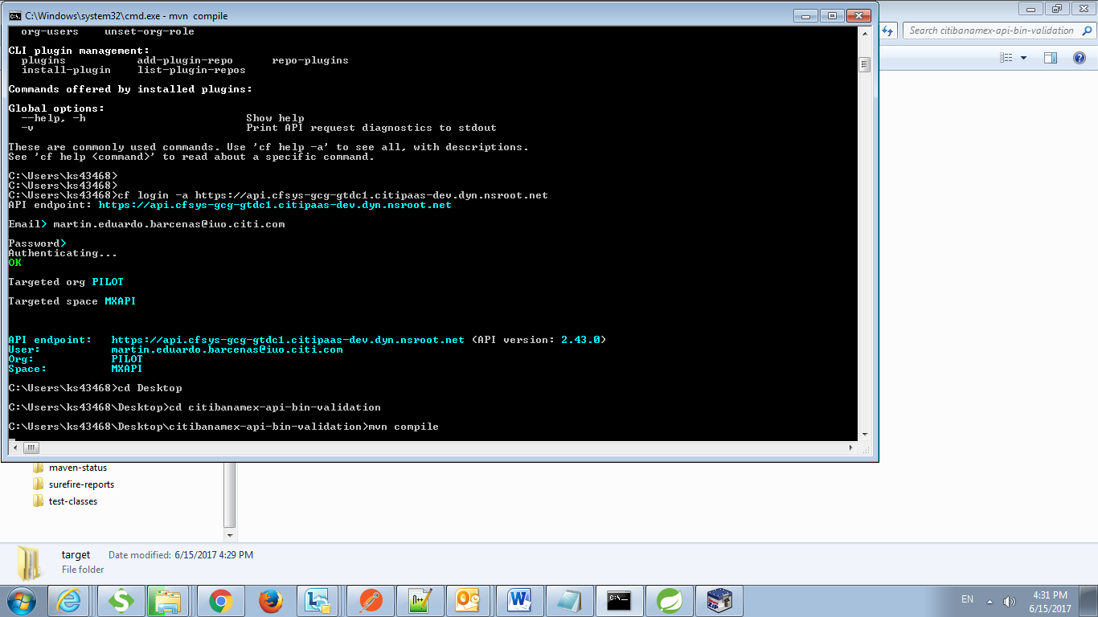

1. Provide your Email and Password
2. Execute : mvn compile
3. Create the “manifest.yaml” file parallel to pom.xml
4. The manifest file contains the following information

---

applications:

- name: citibanamex-api-bin-validation

memory: 1G

instances: 1

buildpack: citi_java_3_8_1_3

1. Execute : mvn clean package – DskipTests
2. Execute : cf push –f manifest.yaml –p target/bin-validation-0.0.1-SNAPSHOT.jar
3. Post success, you can login to the portal and view all the detail(<https://login.run.pivotal.io/login>)

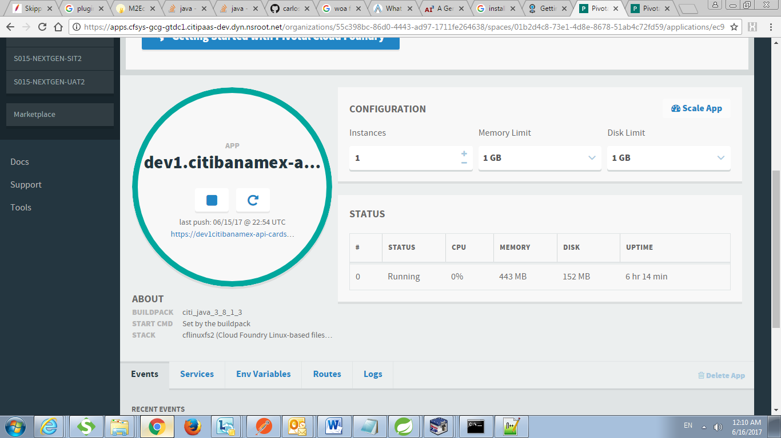

1. You can find URL details from Command prompt as well(post successful deployment you will get those details)
2. Bin Validation URL : <https://citibanamex-api-bin-validation.cfapps-gcg-gtdc1.citipaas-dev.dyn.nsroot.net/>